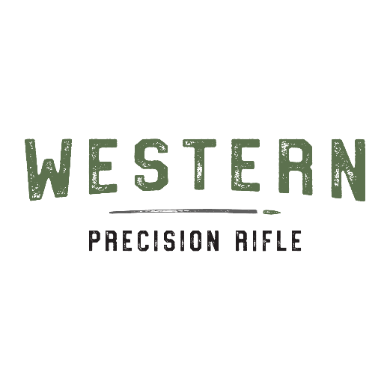
Dear Shooter Name,
Welcome to the 2024 Match Name! a sanctioned Western Precision Rifle match. This match will be held Match Location City, State.
Saturday May 18th safety briefing will start at 8 am with first rounds fired at 8:30 am. This match will consist of up to 10 stages with an absolute max round count of 110. All extra ammo can be used up on Sunday. (Example add your match information)
We have some amazing sponsors……List or delete line
List Amenities along with any other information they may need.
Any questions, please contact Contact Information Name, Email, and Cell Phone

Looking forward to seeing you at the match
Name

Edit Signature! (Insert- Shapes-Line-Freeform and sign with mouse or hand

